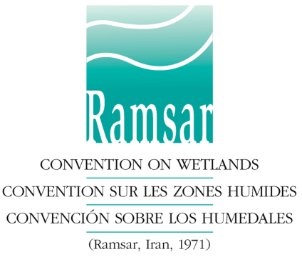

Application form for the Ramsar Wetland Conservation Awards

Please select for ONE of the following categories ONLY:
a) Ramsar Convention Award for Wetland Wise Use or
b) Ramsar Convention Award for Wetland Innovation or
c) Ramsar Convention Award for Young Wetland Champions

Deadline for submission of nominations: 15 July 2014

Having considered the Categories, Criteria and Procedures for the Ramsar Wetland Conservation Awards, I/we wish to submit the following nomination for the consideration of the Standing Committee of the Convention on Wetlands:

I. The nominee

Name:
Title/Position:
Mailing address:

Telephone: ……………………………………………………………………..
Fax:
E-mail:

II. The nominator
Name:
Title/position:
Signature:
Date:
Mailing address:

Telephone: Fax:
E-mail:

III. Referees:
Nominations must be accompanied by letters of recommendation from two independent individuals other than the nominator, who are not related to the nominee and do not work in the same organization, who can assess the nominee’s contributions and who can be contacted by the evaluation panel. N.B. without these letters, a nomination will be considered incomplete and will not be accepted.
Referee 1. Name: .
Title/position:
Mailing address:

Telephone: Fax:
E-mail:
Referee 2. Name: .
Title/position:
Mailing address:

Telephone: Fax:
E-mail:

IV. Summary of the nomination (maximum 250 words)
On the basis of the selection criteria, I/we recommend the nominee in consideration of the following actions/achievements:

V. Attachments:
- This summary must be accompanied by a document of not more than 2,500 words providing the necessary background, explaining how the nomination corresponds to the objectives and criteria of the category of Award, and providing an assessment of the results achieved.
- Nominations must be accompanied by two letters of recommendation (see III above)
- Nominations must be accompanied by at least one high resolution photograph of the nominee (person or team) in electronic form (min. size of 1920x1080 pixels).

Please send this application to the Ramsar Secretariat,
E-mail: award@ramsar.org
Rue Mauverney 28, CH-1196 Gland, Switzerland
Fax: +41 22 999 0169

