**Ramsar Communications Plan 2014-2015**

**Final proposal**

**31 July 2014**

**1. Ramsar mission**

"the conservation and wise use of all wetlands through local and national actions and international cooperation, as a contribution towards achieving sustainable development throughout the world."

**2. Ramsar SWOT analysis**

In the course of a workshop to help define Ramsar’s target groups and messaging on 15 May 2014, the full Secretariat staff put together a comprehensive SWOT analysis for the organization.

The detailed findings of this SWOT analysis are attached as Annex A to this plan. The key findings can be summarised as follows:

**Strengths**

*Brains* – dedicated, diverse and skilled staff, level of experience/expertise

*Extensive network* – 168 Parties, global network, 2,181 Ramsar sites

*Single issue focus* – key, universal issue, flexible approach

*Engagement* – passionate members and governments directly involved

*Sound organisation* – clear structure, good governance

**Weaknesses**

*Limited budget and capacity* – small Secretariat, many tasks, broad plan, perceived dispersion of efforts

*Lack of visibility* – little public recognition, no clear message

*Commitment* – changing government representatives, “soft” decision-making, guidelines not always followed by implementation

*Lack of dynamism* – slow to act, missing opportunities to influence and cooperate

**Opportunities**

*Organization changes* - new team, clarified strategy; clear differentiation

*Increased visibility* - prioritized target groups, outcomes, messages

*Water issues gaining importance* - potential for MDG/SDG goal, influence

*Improved implementation* – engage senior level in governments, increase NFP effectiveness

*Increased partnership activity* – stronger links to other organizations and sectors

*Fundraising* - Private sector potential via both CSR and commercial interests

**Threats**

*Negative global trends* – overall wetlands loss, increasing population and water use

*Lack of wetlands awareness* – benefits not widely known or valued

*Waning of political will* – dropping in priority list, Parties indifferent

*Other organizations* – biodiversity and water conservation space is crowded

**Implications of this analysis**

This SWOT analysis already points out several factors that are instrumental for shaping the communications strategy:

1. Wetland issues have slipped down the international agenda in recent times, but at the same time, there is a once-in-a-generation opportunity to upshift radically by viewing Ramsar’s work in the context of water issues, which are absolutely central to the next generation SDGs.
2. The benefits of wetlands are essentially unknown to the wider public, and need to be phrased in ways that capture the public imagination – and more importantly the policy-maker’s attention. This is a fundamentally different task to capturing a wetlands expert’s imagination.
3. Ramsar is not legally binding. Successful implementation is therefore totally dependent on winning over hearts and minds at all levels. Implementation could be improved by considering exactly what communications support the National Focal Points actually need, and what materials could assist actual policy-makers and decision makers in framing wise policies. To date, all materials have been highly technical and detailed in nature, and aimed purely at an expert audience.

**3. Ramsar collaborator/competitor mapping**

Ramsar is competing for both attention and funding in a very crowded space.

A detailed list of the most active organizations in global wetlands, biodiversity, water and environmental space is included as Annex B.

These collaborator/competitors can be grouped into several clusters:

* IOPs – core organizations that assist in implementation of Ramsar
* International organizations
* Biodiversity, water and environmental conventions
* Biodiversity-related charities and NGOs
* Water-related charities and NGOs

The crowded collaborative space is both a challenge and an opportunity. Given the emerging water focus in the SDGs, Ramsar has the opportunity to position itself as an organization with a dual focus on water and biodiversity issues; and in so doing can position itself at the literal “source” of sustainable development.

**4. Prioritized target groups**

The 2009-2015 CEPA Strategy enumerates some 26 specific target groups, but does not weight their importance. To date, a de facto priority has been placed on technical implementation experts at the country level, with items such as the Wise Use Handbooks.

In the May 15th workshop, these 26 groups where clustered into broad categories according to how the groups actually relate to or contribute to Ramsar and its work. These new broad groupings of possible target groups were classified as follows:

**Those who fund Ramsar:** Government ministers, their advisors; senior policy-makers; Danone-Evian, Biosphere Connections

**Those who actually implement:** implementing experts, local NGOs; site managers/ local communities; IOPs and other international orgs

**Those who’ll implement in future:** future wetlands managers, policy-makers; sites seeking Ramsar designation

**Those who could fund Ramsar:** Private sector in key industries; High net worth individuals/publically prominent individuals (celebrities)

**Those who could be transmitters:** Media; youth generally; general public; women; children; educational institutes

From this, the Secretariat staff selected more specific priority target groups in order of perceived importance to achieving Ramsar’s overall mission:

**1 Government ministers and their advisors, senior policy-makers**

**2 Convention implementers (NFPs, site) and IOPs**

**3 Private sector partners - current and potential**

**4 High net worth individuals/celebrities**

**5. Communications objectives**

Given the SWOT analysis and the situation as outlined, the following objectives/outcomes for communication are proposed for the 2014-2015 period:

**I. Signal a turning point: move wetlands higher on the international agenda**

* Exploit link between wetlands and clean water in context of the emerging SDGs; publically underlining wetlands as “kidneys of the world”
* Position wetlands as (literally) the wellspring/source of sustainable development

**II. Position Ramsar as the “wise man” at the source of sustainable development**

* Use weakness as a strength: people and nations voluntarily take advice
* Act as convener and commentator straddling both biodiversity and water spaces

**III. Provide support tools for effective Convention implementation**

* Aligns with overall CEPA Goals 1 & 2, specifically to support Strategy 2.2.5.:
  + CEPA Goal 1: Communication, education, participation and awareness are used effectively at all levels of the Convention to promote the value of wetlands.
  + CEPA Goal 2: Support and tools have been provided for the effective implementation of national and local wetland-related CEPA activities.
    - Strategy 2.2.5 “Resource materials to support wetland CEPA actions continue to be produced.”

**IV. Widen/deepen private sector cooperation**

* Get more from existing partnerships
* Identify a major new partner; encourage both CSR and commercial activities

**V. Motivate and enable people to act for the wise use of wetlands**

* Corresponds with CEPA Goal 3: People are motivated and enabled to act for the wise use of wetlands.
* Focus specifically on youth as element of the public with greatest potential for influencing future developments
* Use World Wetlands Day to create awareness of wetlands issues and willingness to engage amongst that youth target
* Use the power of celebrity to reach youth and to create awareness of wetlands and their benefits more generally
* Provide clear to-dos for acting locally

**6. Key messages**

The five broad messages that will support the defined objectives are:

* Wetlands and their benefits – why should I care?
* Wetlands loss and its urgency
* Examples of successful wise use policies
* Examples of wise use at site level
* What can I do to take action on wetlands myself?

**7. Ramsar Brand Pyramid**

Summarizing the target groups, outcomes, messaging and Ramsar proposed essence or positioning in the SDG environment:

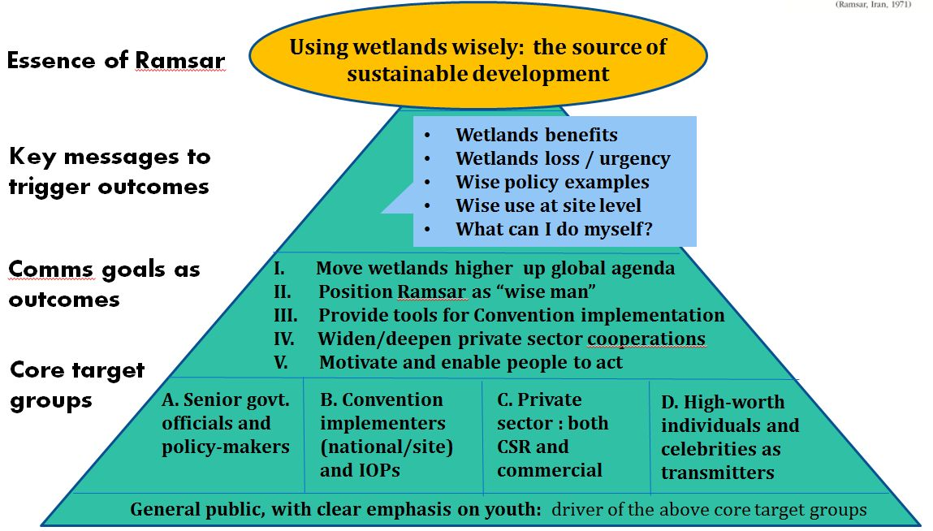

**7.1 Action Plan Objective I:**

**Signal a turning point: move wetlands higher on the international agenda**

*Target*

Government ministers and their advisors, senior policy-makers

Senior management at international organizations

*Key messages*

Wetlands benefits

Urgency of wetlands loss

What can I do?

Successful national and regional policy examples

Advantages of Ramsar site designation

Ramsar value in transboundary and catchment area water issues

*Channels/Activities*

* Online:
  + Website: top-level access to successful policy examples
* Events:
  + Super COP Day: added day on COP to which IOPs and other international organizations are invited
  + Geneva water hub event: work with Swiss government to co-host conference on sustainability and water issues
* Publications:
  + Fact sheet: wetlands benefits
  + Fact sheet: wetlands loss and urgency
  + Fact sheet: wise use policy
  + Matching PowerPoint presentations
* Press engagement:
  + Press release Super COP Day
  + Press release Geneva water hub event

**7.2 Action Plan Objective II:**

**Position Ramsar as the “wise man” at the source of sustainable development**

*Target*

Government ministers and their advisors, senior policy-makers

International organizations and IOPs

*Key messages*

Wetlands benefits

Urgency of wetlands loss

What can I do?

Successful national and regional policy examples

Advantages of Ramsar site designation

Ramsar value in transboundary and catchment area water issues

*Channels/Activities*

* General:
  + Create Ramsar strapline to express positioning
  + Visual identity
    - Develop clean, business-like visual identity including design for
      * Website
      * Powerpoint presentation
      * Stationery
      * Ramsar Site and visitor centre signage
    - Revised Ramsar logo that echoes brand essence
    - Develop mascot that could become associated with the Convention
  + Q&A for staff in giving consistent answers to common questions
  + Create database of photos for use on all materials
* Online:
  + Website: benefits of wetlands, pace of loss and what can I do messages placed at top level of website
  + Google grant: ensure Ramsar returns at top of wetlands-related searches
  + E-newsletter: issue quarterly newsletter targeting decision-makers at key international organizations and policy-makers; framed as a senior level “eye-to-eye” message from SG
  + Social media
    - Twitter account in SG name; “insider” in sustainable development
    - Facebook page offering compelling wetlands stories that people will want to share in their feeds
* Events:
  + Super COP Day: added day on COP to which IOPs and other international organizations are invited
  + Geneva water hub event: work with Swiss government to co-host conference on sustainability and water issues
* Publications:
  + Fact sheet: wetlands benefits
  + Fact sheet: wetlands loss and urgency
  + Matching PowerPoint presentations
* Press engagement:
  + Develop PR strategy:
    - position SG as expert in sustainable development relating to water and biodiversity matters; place interviews
    - assemble press list of contacts at trade title in water, biodiversity and sustainable development space, plus major senior decision-maker titles (e.g. Economist)
    - develop relationships with key global decision-maker titles and major environmental correspondents worldwide
  + Press release Super COP Day
  + Press release Geneva water hub event
* Cooperations:
  + Create “super-league” category of sites that have combined Ramsar/IUCN/UNESCO designation with
    - Super-league logo and signage
    - Single application process?

**7.3 Action Plan Objective III:**

**Provide support tools for effective Convention implementation**

*Target*

Convention implementers (NFPs, site) and IOPs

*Key messages*

Examples of wise management at site level

*Channels/Activities*

* Online:
  + Website: quick access to
    - Case studies on wise use at site level
    - Existing detailed CEPA resources on wise use
* Publications:
  + Fact sheet: wise management at site level
  + Fact sheet: wetlands benefits
  + Fact sheet: wetlands loss and urgency
  + Matching PowerPoint presentations
  + Wise Use Handbooks: review for overlap, level of detail and consider consolidating in next update
* Press engagement:
  + Press release on Ramsar Site designations
* Ramsar Site and visitor centre signage
  + Develop layout and guidelines for consistent site signage (as part of visual identity review)

**7.4 Action Plan Objective IV:**

**Widen/deepen private sector cooperation**

*Target*

Existing partners in Danone, Star Alliance; evaluate candidates for a third major private sector cooperation drawn from a priority industry with wetlands interests

*Key messages*

Wetlands benefits

Urgency of wetlands loss

What can I do?

What can $1 million achieve for wetlands

*Channels/Activities*

* Expand Danone/Evian cooperation
  + Common “pure source” messaging across all joint activities to support Ramsar positioning and Evian’s purity/balance
  + Strengthen cooperation on three main pillars
    - Pre-Curieux Ramsar site as unique purity credential – make into a “super-site” with coordinated branding and activities in the catchment area
    - Ramsar Awards with Youth Award coverage
    - World Wetlands Day (detailed in concept presentation)
* Expand Biosphere Connections cooperation
  + Take advantage of all channels in agreement:
    - Editorial and advertising in in-flight magazines
    - Use of Ramsar video
    - Promotion of WWD photo contest
* Evaluate options for third major partnership drawn from one of priority industries (e.g. tourism, water sports)
* Online:
  + Website: top-level access to private sector partnership activities
* Publications:
  + Fact sheet: what can I do?
  + Fact sheet: wetlands benefits
  + Fact sheet: wetlands loss and urgency
  + Matching PowerPoint presentations
* Press engagement:
  + Press release on new partnership agreements

**7.5. Action Plan Objective V:**

**Enhance public awareness of benefits of wetlands and willingness to act**

*Target*

Focus on youth (ages 14-25) as future leaders and decision-makers, and who form a priority target group for Danone, who are funding World Wetlands Day, the key activity on this front.

More broadly, acquire a celebrity who could act as transmitter to wider public and magnet for press coverage.

*Key messages*

Wetlands benefits

Urgency of wetlands loss

What can I do?

*Channels/Activities*

* Celebrity engagement:
  + Identify and approach a celebrity who could act as voice of Ramsar
  + Jointly develop a plan for using their awareness as transmitter
    - E.g. Richard Branson and Necker Island site designation
* Online:
  + Website:
    - benefits of wetlands, pace of loss and what can I do messages placed at top level of Ramsar website
  + World Wetlands Day micro-site with key functionalities for
    - materials distribution,
    - photo contest entry and voting
    - reporting of local events
    - summary reporting of key metrics
  + Google grant: ensure Ramsar returns at top of wetlands-related searches
* Events:
  + World Wetlands Day: the key annual event for engaging with public: create single event to encourage direct engagement with wetlands in a 24-hour period *(full concept detailed in WWD presentation)*
    - Photo contest as focus for worldwide events
    - Prominent Ramsar site designation
    - Optional focal event in Geneva or Evian
    - Support materials for organizers and for teachers
* Publications:
  + Organizers guide to WWD
  + Teacher guide: field trip guide and Powerpoint
  + Logos and use guidelines
  + Poster and flyer (with locally-adaptable versions)
  + Fact sheet: wetlands benefits
  + Fact sheet: wetlands loss and urgency
  + Fact sheet: what can I do?
* Video
  + Wetlands: why should I care and what can I do?
* Press engagement:
  + Press release on WWD photo contest
  + Press release on prominent Ramsar site designation

**Annex A: Results of SWOT Analysis**

From workshop on 15 May 2014

**Strengths**

**Brains**

Dedicated, passionate Secretariat staff

Diversity, experience, skill and competence of staff

40 years of experience and knowledge

**Extensive network**

Broad convention – 168 Parties

Global network presence on the ground

2,181 Ramsar sites and growing

**Single issue focus**

Key and universal development subject

Water issue of vital importance

Flexible approach fits varied situations

**Engagement**

Many passionate members

Partners are engaged

Governments are directly involved

**Sound organisation**

Clear Convention structure

Cross-sectoral and integrative approach

Strong governance structure

Decision-making by concensus

Excellent technical guidelines

**Weaknesses**

**Limited budget and capacity**

Strategic plan too broad in scope

Small secretariat with many tasks

Priorities not always clear

Perceived dispersion of efforts

**Lack of visibility**

Very little public recognition

No clear message

**Unclear levels of commitment**

Government representatives changing

Lack of engagement from Parties

Convention with “soft” concensus-based enforcement

Lack of data about sites

Just another government Convention

Guidelines often not followed up with implementation

**Lack of dynamism**

Reporting to governments

Slow to act; not agile or open to change

Missing opportunities to influence

Not reaching out to related sectors

Too many languages leading to misinterpretations

**Annex A: Results of SWOT Analysis**

**Opportunities**

**Organization changes**

New team, clarified strategy

Clear differentiation/role for Ramsar

**Increased visibility**

Prioritized target groups, outcomes

Clear messages to trigger outcomes

Engage public via Ramsar sites

**Water issues moving up the agenda** Potential for MDG/SDG goal

Exploit global trends in env. policy

Exert influence on national policies

**Improved implementation**

Engage with governments at senior level

Increase effectiveness of NFPs

More teamwork across regions/themes

Stengthen NGO support in countries

**Increased partnership activity**

Stronger links to other organizations and industry sectors

Attention-grabbing water partnership

**Fundraising** Private sector potential (CSR and profit)

Forge strong link to tourism

**Threats**

**Negative global mega-trends**

Current loss of wetlands is exceeding capacity to conserve

World population growth and related increasing demand on water

Short term gain seen as more important than long-term sustainability

**Lack of wetlands awareness**

No widespread knowledge of ecosystem benefits; thus wetlands are not valued

**Waning of political will**

Indifference of many Parties

Wetlands has slipped down the global priority list

Growing demands on Ramsar without financial and human resources

**Other organizations**

Crowded biodiversity conservation space

Many organizations with similar aims

Many of those better resourced and perceived as more valuable by clients

**Annex B: Collaborator/competitor overview 1**

**Annex B: Collaborator/competitor overview 2**



**Annex B: Collaborator/competitor overview 3**



**Annex C: Communication Overview:**

**Goals- Target Groups-Messages-Measures**

