14th Meeting of the Conference of the Contracting Parties

to the Ramsar Convention on Wetlands

“Wetlands Actions for People and Nature”

Wuhan, China and Geneva, Switzerland, 5-13 November 2022

Ramsar COP14 Doc.18.20 Rev.2 draft

Note from the Secretariat:

At the resumed session of its 59th meeting, the Standing Committee in Decision SC59/2022-31 accepted the revised draft resolution in document SC59/2022 Doc.24.1 Rev.1 on Protection, management and restoration of wetlands as [nature-based solutions] [ecosystem-based approaches] to address the climate crisis and agreed to forward it to COP14 for its consideration.

Draft resolution on integrated approaches for the conservation, restoration, sustainable use and management
of wetlands as [nature-based solutions] [and] [or] [ecosystem-based approaches]
to support sustainable development

Submitted by Spain

1. RECALLING:
a. Resolution XI.14 on Climate change and wetlands: implications for the Ramsar Convention on Wetlands, which urges Contracting Parties to maintain or improve the ecological character of wetlands to, inter alia, promote the ability of wetlands to contribute to ecosystem-based adaptation to climate change and to sequester and store carbon as important responses for climate change mitigation;
b. Resolution XIII.14 on Promoting conservation, restoration and sustainable management of coastal blue-carbon ecosystems, highlighting the value of some wetland types as natural carbon sinks;
c.
d. the Ramsar Strategic Plan 2016-2024, highlighting the important ecosystem services that wetlands provide, to contribute to halting biodiversity loss, food security, healthy living, water quality and supply, water security, disaster risk reduction, adaptation and mitigation to climate change; and
f. Resoution UNEP/EA.5/Res.5 on Nature-based Solutions for Sustainable Development.

2. TAKING NOTE OF:
a. the United Nations Framework Convention on Climate Change (UNFCCC) and the Paris Agreement adopted thereunder, as well as the outcome of the 25th UNFCCC Conference of the Parties;
b. the final agreement of COP 26 of the UNFCCC, known as the Glasgow Climate Pact, which emphazised the importance of “protecting, conserving and restoring nature and ecosystem to achieve the Paris Agreement temperaqture goald, including through forests and other terrestrial and marine ecosystemsacting as sinks and reservoirs of greenhouse gases”;
c. UNEA Resolution UNEP/EA.5/Res.5 on “Nature-based solutions for supporting sustainable developemtne”; []) recognizing the need for analysis of their effects, including in the long term, and acknowledging that they do not replace the need for rapid, deep and sustained reductions in greenhouse gas emissions, but can improve action for adaptation and resilience to and mitigation of climate change and its impacte and recalling the need for further intergovernmental consultations to assess the implementation of Nature-based solutions [and recognized that nature-based solutions, inter alia, respect social and environmental safgeguards (UNEP/EA.5/Res.5)]
d. the entry into force of the UN Decade for the restoration of ecosystems 2021-2030 and the UN Ocean Decade;
d. the IPCC as the primary international body for assessing the science related to climate change, providing policy-makers with regular assessments of the scientific basis of climate change, its impacts and future rsiks, and options for adaptation and mitigation, as highlighted by Resolution XIII.14;
e. the Global Assessment report on biodiversity and ecosystem services of the Intergovernmental Science-Policy Platform on Biodiversity and Ecosystem Services, the Global Wetland Outlook 2021;
f. the process for the preparation of the post-2020 Global Biodiversity Framework adopted by the Conference of the Parties to the Convention on Biological Diversity (CBD/COP/DEC/14/34);
g. the Sixth Assessment Cycle of the Intergovernmental Panel on Climate Change (IPCC AC6) (Working Group 1, 2 and 3 reports);
h. the UN Water Development Report on Nature-based Solutions for Water of 2018;
i. the United Nations Office for Disaster Risk Reduction (UNDRR) report on Words into Action: Nature-based solutions for disaster risk reduction, of 2021;
i.bis the learned lessons from the implementation at national and sub-national levels of nature based solutions and ecosystem based approaches;
and
k. the progress made at COP25 of the UNFCCC, known as “the Blue COP”, through which the roles of the ocean and marine-coastal ecosystems were recognized for the first time as essential elements to mitigate the effects of climate change and promote compliance with the nationally determined contributions (NDCs);

2bis. ALSO RECALLING
- the Global Wetland Outlook 2021 Special Edition identifies the role of wetlands as nature-based solutions;
b. the policy and other recommendations relating to wetlands and climate in STRP publications specifically: Policy Brief 5 on restoring drained peatlands, Policy Brief 6 on transforming agriculture to sustain wetlands and people, Briefing Note 10 on wetland restoration for climate change resilience, and Briefing Note 12 on blue carbon ecosystems; and
c. The findings of the IPBES-IPCC co-sponsored workshop report on biodiversity and climate change;

3. AWARE that:
a. climate change is accelerating and already affecting every region across the globe, with particular consequences in developing countries, with human influence contributing to many observed changes in weather and climate extremes and that global temperature will continue to increase until at least mid-century under all emission scenarios considered by the IPCC;
b. only 13% of the wetlands that existed in 1700 remain in 2000 (IPBES 7, 2019), wetlands have globally decreased by 35% since 1970 and that the trend of decline has not been effectively stopped (Global Wetland Outlook 2018; IPBES 7, 2019), and that this trend will impact the achievement of the United Nations Sustainable Development Goals for 2030, the UNFCCC, Paris Agreement and the Convention on Biological Diversity and its Global Biodiversity Framework in development;
c. progress in adaptation planning and implementation has been observed across all sectors and regions, generating multiple benefits. However, adaptation progress is unevenly distributed with observed adaptation gaps;
d. according to the IPCC, adaptation to water-related risks and impacts makes up the majority of all documented adaptation;
e. enhancing natural water retention such as by restoring wetlands can reduce flood risk by storing water and slowing water flow, in most circumstances;
f. coastal wetlands protect against coastal erosion and flooding associated with storms and sea level rise;
g. by protecting and restoring wetlands, which are included in the IPCC’s internationally recognized guidelines for national greenhouse gas (GHG) emissions and removals, we are safeguarding important carbon sinks, which can support countries in reaching mitigation targets, in line with national circumstances and priorities and with due regard to the obligations set out under the UNFCCC and the Paris Agreement and their relevant principles;

hbis. the ongoing loss of natural wetlands (especially peatlands and blue carbon coastal ecosystems) is contributing significantly to global emissions, further exacerbating climate change;
h ter. the protection, conservation and restoration of wetlands must play a vital role in climate change mitigation, adaptation and resilience, and is necessary to limit global warming to 1.5 degrees; and
; and
j.
k. due to the downstream flow of rivers in the watersheds of different regions, due to the impacts of climate change, and its effects on the biological resources and wetlands of these watersheds.,
l. of the prersistent levels of poverty, including extreme poverty, across wetland-dependen communities, in particular in developing countries, thus stressing the need for the development of conservation, restoration and sustainable use and management use policies that are supportive of sustainable livelihoods, including by mapping employment opportunities from the sustainable use of wetlands and promoting biodiversity-based products and value chains from marine and coastal ecosystems.

4. AFFIRMS:
a. the need to promote greater alignment between climate and wetlands policy;
a. that the protection, restoration and wise use of well-preserved and restored wetlands are important for biodiversity and people to thrive in the coming decades and adapt to and mitigate the new conditions imposed by climate change as it has been demonstrated for water bird populations;
.bis that the restoration of natural wetland ecosystems has the significant potential to mitigate the effects of climate change and improve resilience to the effects of climate change, including coastal protection against rising sea levels, and
- the key role played by wetlands in providing important ecosystem services and their potential role as [nature-based solutions] [and] [or] [ecosystem-based approaches], and aware of the need to conserve, restore and manage wetlands sustainably [the key role played by wetlands in providing crucial ecosystem services and their potential to contribute to nature-based climate change adaptation, carbon sequestration, and to reducing or halting the release of stored carbon that can result from the degradation and loss of wetlands]

4.bis Acknowledging that nature-based solutions do not replace the need for rapid deep and sustained reductions in greenhouse gas emissions but may contribute significantly to adaptation and mitigation of climate change and its impacts.

THE CONFERENCE OF CONTRACTING PARTIES

5. RECOGNIZES the potentialvalue of nature-based solutions in achieving multiple benefits, including for human wellbeing and biodiversity, by addressing social, economic and environmental challenges through protecting, conserving, restoring, sustainable use and management of wetlands, taking into account national circumstances and priorities and the mandates of existing multilateral environmental agreements

6. ENCOURAGES the Contracting Parties, as applicable and where relevant, in accordance with local, national and regional circumstances, consistent with the 2030 Agenda for Sustainable Development, to:
a. promote wetland conservation and wise use through nature-based solutions for mitigation and adaptation, as integrated approaches to simultaneously address biodiversity loss, wetland degradation, water abstraction and scarcity and risks associated with the impacts of climate change as urgent, eliminate or modify policies that contribute to wetland loss, and pursue policies and projects to conserve and restore wetlands in the coming years;
b. [consider [develop and implement] [to scale up the implementation of nature-based solutions including] cost-effective wetland nature-based solutions when identifying [developing] measures to regulate carbon emissions, to mitigate climate impacts and reduce vulnerability to climate change, to secure sound water resources management, sustainable food production, and other ecosystem;]
c. enhance the conservation and the restoration of wetlands as a means to achieve a range of water-related objectives, including ambitious, ecosystem-based and integrated sustainable water management and hydro-morphological restoration measures of connected watersheds;
d. put in place financial incentives to support the efforts of Indigenous Peoples and local communities and support their involvement to sustainably conserve, manageuse and restore wetlands;
e. consider measures that address negative impacts on wetland uses for climate adaption, in accordance with national policies; and
f. [promote [nature-based solutions] [and] [or] [ecosystem-based approaches] into account under the Ramsar Convention to include them in their domestic biodiversity and climate change frameworks, including to support climate change mitigation and adaptation, but also in all relevant sectoral policies as approved by the International Union for Conservation of Nature (IUCN) World Conservation Congress 2020 [into sectoral policies and plans where appropriate, such as] (WCC-2020-Res-031);]

7. RECOMMENDS that all Contracting Parties, as applicable and tho the extent possible, promote implement, monitor, evaluate and update as needed the following nature-based solution wetland restoration activities, in accordance with local, national and regional circumstances, consistent with the 2030 Agenda for Sustainable Development:
a. develop and maintain a knowledge base on wetland extentand their conservation status in the region as a regional reference base to assess progress and prioritize restoration actions;
b. develop a knowledge base on the contribution and future potential of carbon fluxes in wetlands in climate mitigation, including coastal and marine systems, [blue carbon and peatland ecosystems]and on vulnerability, fort policy recommendations that would guide restoration efforts [targeted restoration approaches that would co-benefit biodiversity and climate change adaptation and mitigation];
c. identify, upscale and promote the appropriate application of successful wetland nature-based solution restoration projects that are geographically relevant, other sites designated as a priority for restoration and organize exchanges of good practices and lessons learnt; and
d. promote wetlands restoration capacitybuilding ;

7bis. RECOGNIZES the importance of establishing innovative financialmechanisms to scale up the conservation, restoration, sustainable use and management of wetlands and to assign value to conservation, restoration, sustainable use and management interventions, such as payments for ecosystem services schemes, and to engage indigenous peoples and local communities and the private sector, among other relevant stakeholders, and ENCOURAGES Parties to develop payments for environmental services schemes, among other innovative financial mechanisms, in line with national circumstances and priorities and consistent with relevant international obligations, to generate new and additional resources for the implementation of the Convention.

7ter. RECOGNIZES the potential of sustainable and environmentally sound bio-based products and value chains from wetlands and their importance to support sustainable livelihoods and poverty alleviation efforts and scale up the conservation, restoration, sustainable use and management of wetlands, enhancing the social, economic and environmental benefits from wetlands and ENCOURAGES countries to map biodiversity-based products and value chains from wetlands that could unlock investments in wetlands conservation and restoration and support their promotion

7quater. RECOGNIZES the need to identify options for supporting sustainable investment the restoration, conservation, sustainable use and managament of wetalds in developing countries and CALLS UPON Parties to share information on bilateral and multilateral sources of finance to enable developing countries to scale up the implementation of the present resolution.

[8. REQUESTS the Ramsar Secretariat subject to available resources,to establish a community of practice on wetland nature-based solutions for cooperation among regional initiatives and other stakeholders by sharing scientific and technical support and information on accessing financial resources;]

[9. INSTRUCTS the Ramsar Secretariat to liaise with relevant international conventions and organizations including UNISDR, UNFCCC bodies,CBD bodies, and the United Nationals Environment Programme, within their respective mandates, to promote protection,conservation, restoration, sustainable use and management of wetlandsas [nature-based solutions] and [or] ecosystem-based approaches] for climate change mitigation and adaptation, water provision and flood management which simultaneously provide other benefits, including for biodiversity and human well-being;]

[10. URGES the Secretariat of the Ramsar Convention to liaise with other international institutions promoting wetland restoration and other [nature-based solutions] [and] [or] [ecosystem-based approaches], , in the context of their respective mandates and as part of strengthening the global response to the threat of climate change, to identify a range of financial schemes (i.e. public-private partnerships, payments for ecosystem services, dedicated grants, private sector investments in carbon financing, etc.) to support urgent large-scale wetland restoration efforts; and]

11. REQUESTS that the Scientific and Technical Review Panel (STRP), if resources are available, consistent with its scope, mandate and priority thematic work areas for 2022-2025, consider continuing its work on wetlands, focusing on wetland protection and restoration as a nature-based solution [or ecosystem-based approach] for climate mitigation and adaptation, as a high priority, inter alia by:
a. undertaking a desktop study of success stories of wetlands as [nature-based solutions] [and] [or] [ecosystem-based approaches] contributing to climate change mitigation and adaptation and disaster risk reduction; and
b. [developing a technical handbook on a wide range of potentially applicable nature-based solutions to wetlands.]
c. mapping biodiversity-based products and value chains from wetlands that could unlock investments in wetland conservation and restoration, thus generating multiple social, economic and environmental benefits;

[ Annex 1
Technical Annex

- KNOWLEDGE ON MEDITERRANEAN WETLAND TYPES AND EXTENT

There has been some recent progress in mapping the wetland ecosystem in the Mediterranean region, and assessing its condition. However, the integrated assessment of inland and coastal wetlands is not always possible due to misleading definitions of wetlands, scattered data availability for certain habitats and varying accuracies for the different parts of the basin. Whereas wetlands in some EU South-West and Balkan countries and Mediterranean islands have been assessed recently, more detailed information still to be collected for the Eastern and Southern parts of the Mediterranean.

- Need for comprehensive wetland habitat reporting

The major habitat types hosted by the Northern Mediterranean wetlands (figure 1a) are varied and reported by EEA countries in compliance with parallel policy frameworks and nomenclatures, depending on their association to the terrestrial or marine realms, which makes a comprehensive assessment of wetland habitats difficult to implement. Given the current mapping and reporting limitations, for the Southern Mediterranean wetlands (figure 1b), only three broad wetland types can be distinguished at present.

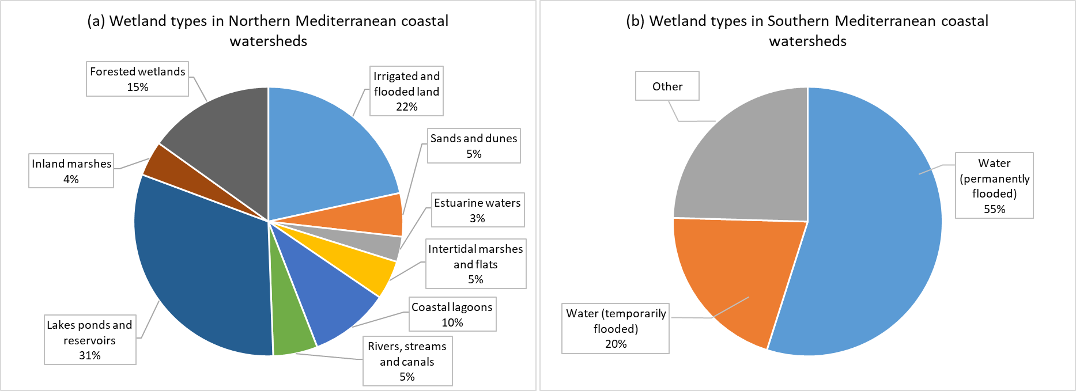
Figure 1: Percentage of wetland habitat typology in the coastal watersheds draining in the northern (a) and southern parts (b) of the Mediterranean basin².

- Need for more accurate Southern/Eastern Mediterranean data

The boundaries of the current Mediterranean wetland study area are defined by the watersheds which drain into the Mediterranean Sea according to the HydroSHEDS dataset and the wetland coverage is presented in Figure 2.
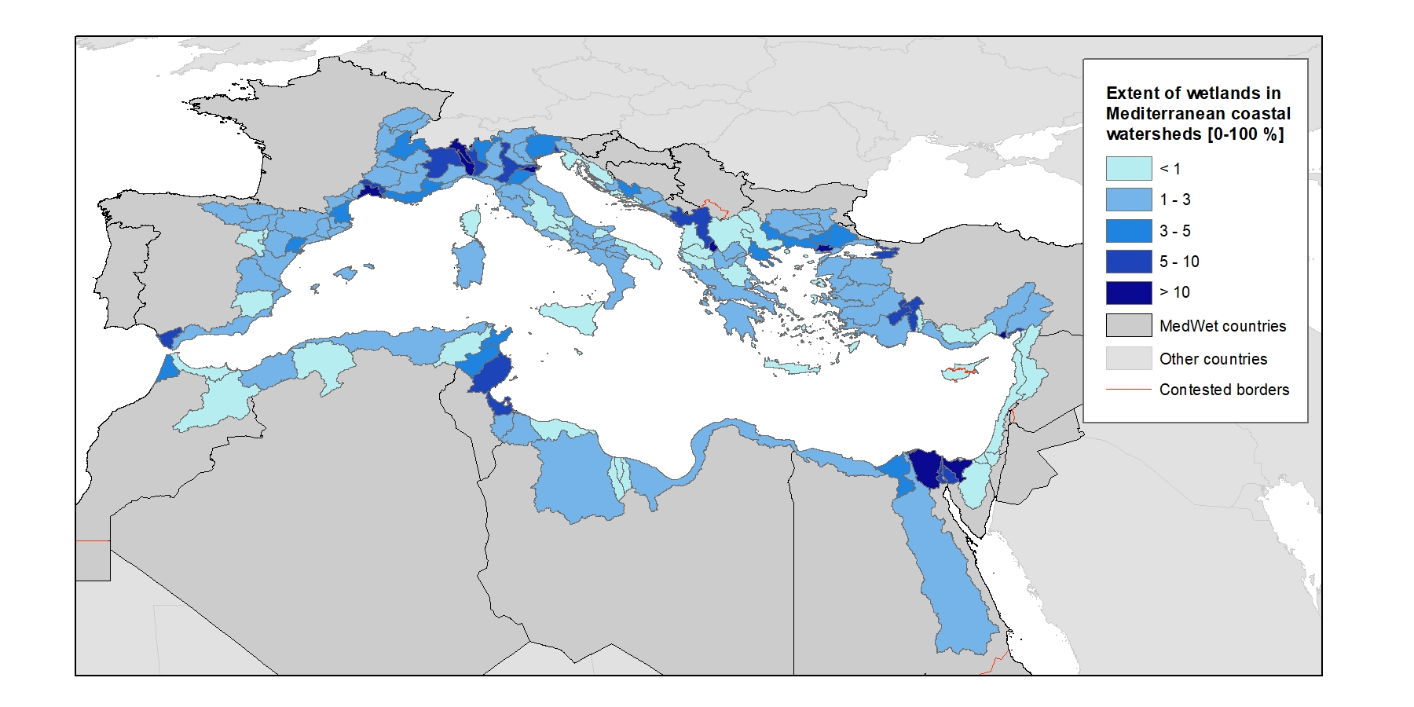 | Figure 2: The total area of the wetlands ecosystem delimited for this study² covers 45,035 km² in the whole basin for watersheds draining into the Mediterranean
This recent spatial assessment aims to answer the need for a Mediterranean-wide wetland ecosystem map and knowledge base. It is the result of a participatory effort by a partnership of key Mediterranean institutions and co-financed by the Interreg Mediterranean programme and the MAVA Foundation. This knowledge base constitutes a first basis to understand the condition of Mediterranean wetlands and, due to the limited availability of accurate and harmonised information especially for the Southern/Eastern regions, requires further dedicated and collaborative efforts to further enrich it in time as data become available.

Such an effort was done for the Balkan Mediterranean region within the project WetMainAreas, whose resulting database has been added to the regional knowledge base presented here. Among other things, its outcomes allowed to highlight the importance of small and medium-sized wetlands. Although they occupy only 3% of total wetland area in the monitored region (Albania, Bulgaria, Cyprus, Greece, North Macedonia), small wetland sites (below 8 ha) represent ¾ of the total number of wetland sites. These numerous small wetlands create a valuable network of corridors and stepping stones, essential for species movement, migration and dispersal. When they are found in heavily urbanised and agricultural areas, they form islands of biodiversity and natural green infrastructures offering multiple services (water storage, recreation, adaptation to climate change, habitat for species).

Also, 1/3 of total wetland in the Balkan Mediterranean region is located in unprotected land with very high value for biodiversity. These wetlands should be integrated in conservation action plans for protected habitats and species of Natura 2000 sites, Emerald sites, National Parks and OECMs.

- KNOWLEDGE ON THE CONDITION AND PRESSURES ON MEDITERRANEAN WETLAND HABITATS

- Need to decrease pressures to reverse declining and unfavourable trends for wetlands

At the pan-Mediterranean level (based on a sample of more than 400 sites), the Mediterranean Wetlands Observatory has reported that natural wetland habitats have decreased by 48% since 1970 (MWO-2, 2018). At the same time, since 1970, urbanisation increased by 294% and agricultural areas by 42%. Most of these losses were caused by urbanisation and agricultural expansion causing the transformation of natural wetlands into human-made wetlands, croplands, built-up areas and sea waters (respectively 47%, 46%, 5% and 2% of the conversions).

Human demography growth is considered as one of the main drivers leading to natural wetlands loss and degradation. The MWO has reported that, in the Mediterranean region, the population has increased by almost one-third since 1990 and is still on an upward trend. Coastal areas and especially coastal lagoons seem to be the most impacted (Figure 3).

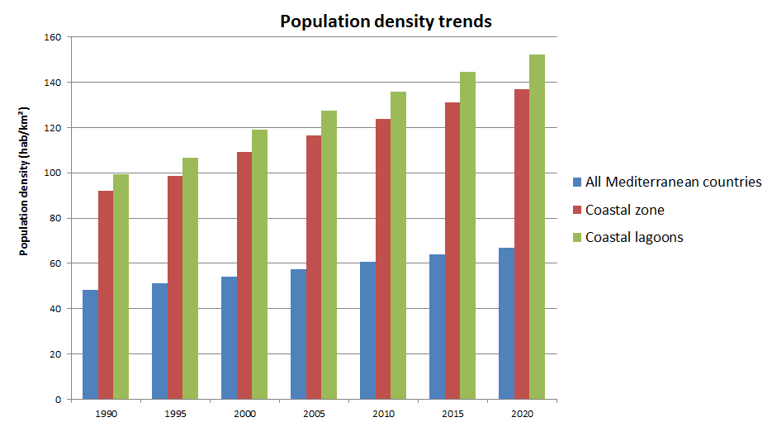
Figure 3: Trend in average density of human populations around the Mediterranean Basin (MWO, 2022)

- As pressures are maintained high, unfavourable condition of wetland habitats and species is still dominant, despite slight good signs at local scale

The condition of the EU-Mediterranean coastal wetland habitat types protected under the Habitat directive has been assessed from reported data under Art.17 of the Directive, for the period 2013-2018. EU Member States reported the information on the Conservation status and trends of the 8 habitat types associated with coastal wetland ecosystems in the Mediterranean bio-geographical region, using a standard methodology based on four parameters representing different aspects of the habitat conditions, namely: “Range”, “Area”, “Structure & Function”, and “Future Prospects”. The EU biogeographical conservation status for those habitats reflects their overall condition by combining the Member State data or by weighting the Member State assessments, in order to reflect the status and proportion of the habitat type present in each Member State. The indicator reflects the number of habitat types reported as Favourable, Unfavourable-Inadequate, Unfavourable-Bad, and Unknown.

The assessment of EU Mediterranean coastal wetland habitat types provides evidence on the dire condition of these habitats (figure 4a), where 69% of the assessed habitats show Unfavourable conservation status (Unfavourable-bad, Unfavourable-inadequate), with a high percentage of knowledge gaps (17% unknown) and only a small share (14%) of the assessed habitats showing signs of effective conservation.

Moreover, the conservation trends of the EU-Mediterranean coastal wetland habitats show an alarming declining (30%) and a majority of stable trends (31%), which indicate that the condition of ecosystems under legal designation under the EU´s Habitat directive assessed as unfavourable (figure 4b) presents worrying signs; in fact, improving trends are reported for only 5% of the reported assessments by EU Member States.

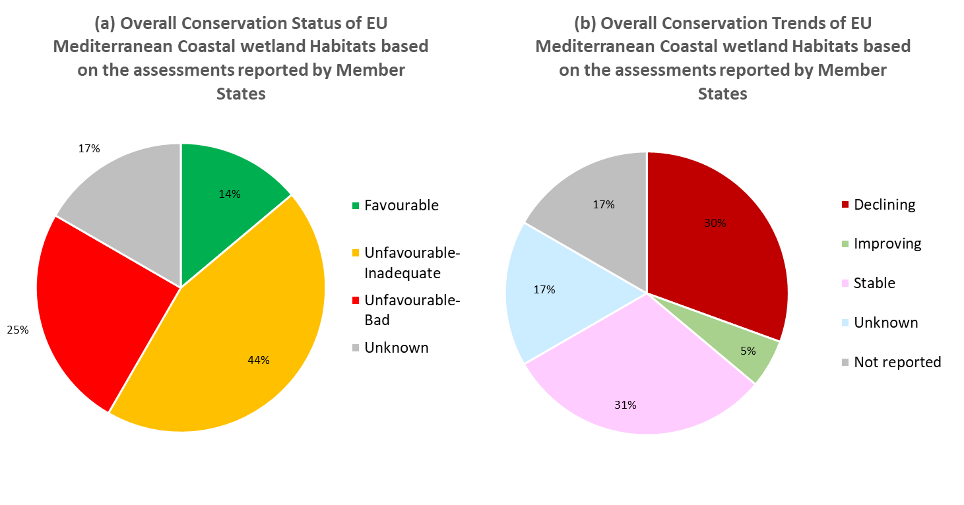 | Figure 4: Condition and conservation trends of the coastal wetland habitats in the Mediterranean part of the EU27 domain, for the period 2013-2018: percentage of Conservation status (a) reported as Favourable, Unfavourable-Inadequate, Unfavourable-Bad or Unknown, for the period 2013-2018. Conservation trends (b) reported as Improving, Stable, Declining or Unknown
These decreasing trends of natural wetland habitats, together with other factors like climate change, have negatively impacted the abundance and distribution of wetland-dependent species (MWO-2, 2018). The wetland related biodiversity in the region is at high risk, as almost half of the freshwater endemic species in the whole MedWet region is threatened with extinction. According to the MWO-2, 2018, the Living Planet Index calculated for these species in the Mediterranean region (LPI-Med) shows a long-term decline since 1990 (-15%), mainly driven by negative trends of the “Amphibian, Reptiles and Mammals” group (-35%) and the wetland-relevant “Fishes” group (-34%).

Nonetheless, the overall trend of the Living Planet Index seems to be improving since the mid-2000s, mostly due to increases in water-bird populations especially in regions where concrete conservation actions have been undertaken at local scale.

- More balanced protection figures across wetland habitat types and geographical regions are required to re-establish wetland functions

The analysis on the level of protection of watershed wetlands according to the type of habitats shows unbalance, with certain habitat types like estuarine waters, coastal lagoons and intertidal marshes and flats on the Mediterranean northern shore (figure 5) having a higher percentage of protection, including the overlapping of several protection figures and a lack of official designation for irrigated and flooded lands.

An equivalent analysis to include southern Mediterranean regions and achieve a regional assessment per habitat type is not possible with the current knowledge. Nevertheless, according to available data, the level of protection in the southern part of the basin is much lower than in the northern part (figure 6): only 21% of the wetland ecosystem area in the southern shores of the Mediterranean region is currently classified as protected area.

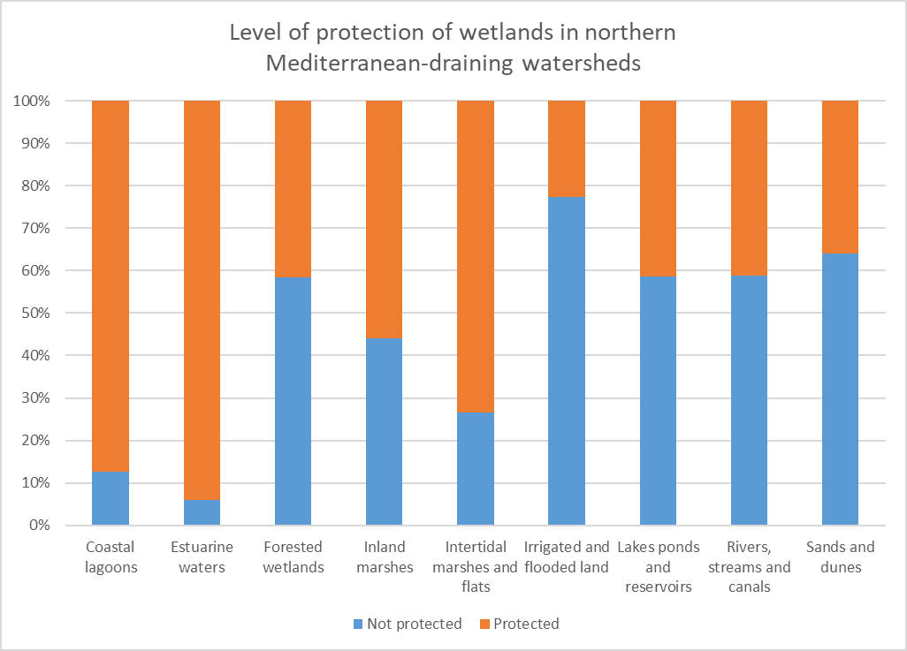 | Figure 5: Wetlands in watersheds draining from the northern part of the Mediterranean basin: percentage of protected areas (Protected Planet database) for each habitat type

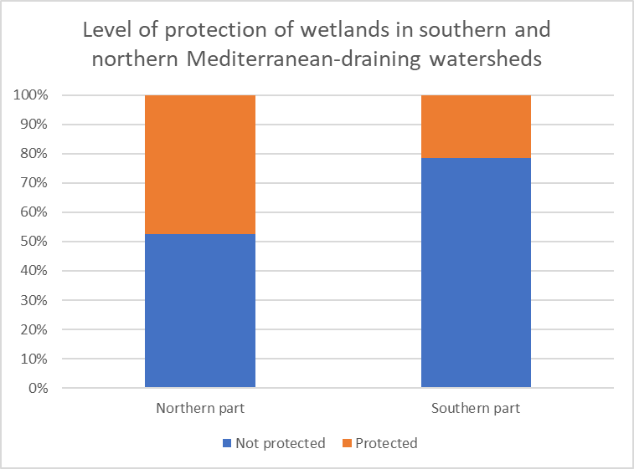
Figure 6: Wetlands in watersheds draining from the southern and northern part of the Mediterranean basin: percentage of protected areas (Protected Planet database¹⁰)

This assessment demonstrates that tangible improvements in the condition of Mediterranean coastal wetlands and the reestablishment of their functions to provide key services such as water provision and water purification to ensure food security requires an increase in the level of protection and therefore the associated management, monitoring and restoration measures.

- THE ROLE OF WETLANDS RELATED TO CARBON

Wetlands have demonstrated to be one of the most efficient long-term carbon stocks (figure 7) compared to other ecosystems. According to the meta-analysis developed by ETC-UMA, wetlands have a high blue carbon sequestration potential when in a good environmental status and effectively managed, particularly seagrass meadows and salt marshes, and are a powerful tool to address the environmental, climatic and socio-economic challenges in the region. Degraded wetlands on the contrary can become carbon emission sources, which proves that the conservation, effective management and restoration of wetlands are effective low-cost nature-based solutions against the impacts of climate change, including water scarcity.

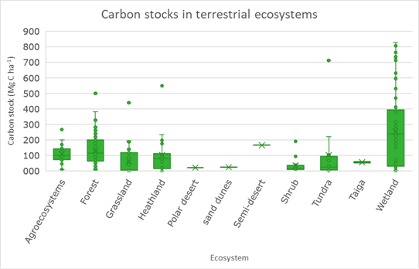 | Figure 7: Carbon stocks per type of terrestrial ecosystem (from Hendriks et al., 2020)

- POTENTIAL RESTORATION SITES IN THE MEDITERRANEAN REGION

A comprehensive pan-Mediterranean map of potential areas for wetlands restoration has been developed by the MWO. This result could be used as a baseline to locate and delineate the main transformed wetlands that could be regained, and to qualitatively estimate the needed effort for their restoration (Figure 8). This map is mainly based on the surface hydro-ecological characteristics of wetlands, combined with the current land use, the conservation status of the existing wetlands and the main management policy frameworks in place (e.g. protected areas). These results could also be downscaled at national levels.

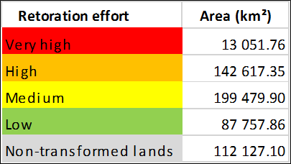
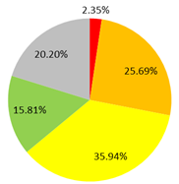
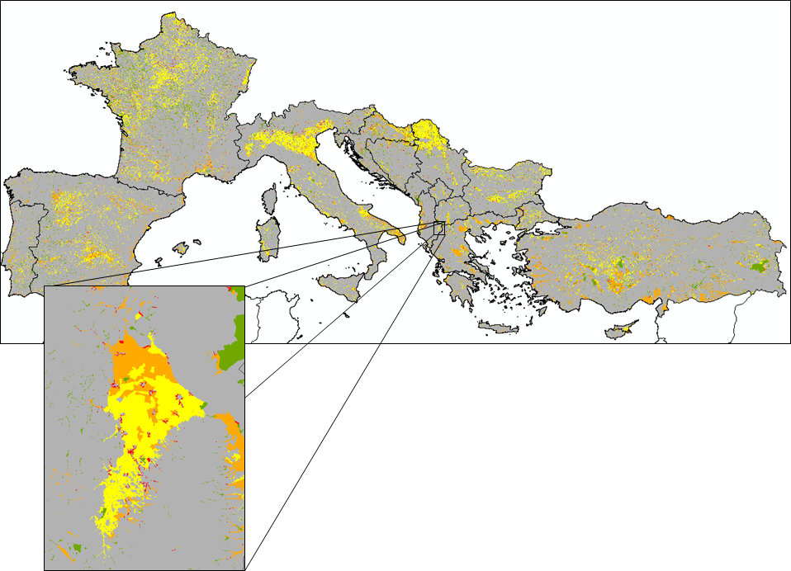
Figure 8: Wetlands restoration estimated efforts for the European Mediterranean countries, with a zoom on Maliqi Marshes, an ancient wetland in Albania that has been drained for crops development (MWO, 2022)

An online survey carried out in 2021 has identified over 220 wetland sites from 24 countries that have potential for restoration activities. This potential wetland restoration could improve over 230,000 ha of degraded wetlands in the Mediterranean basin. The details and potential sites from this 2021 survey can be found at: https://www.wwf.es/nuestro_trabajo/agua/humedales/potential_wetlands_to_be_restored_in_mediterranean_countries/.
Other institutions and initiatives are also increasingly addressing passive and active restoration good practices under the UN Restoration Decade to promote wetlands as Nature-based solutions to the current biodiversity, water and climate change crises in the Mediterranean that urgently need support.

V. EFFECTIVE MANAGEMENT AND RESTORATION PRIORITISATION

The multiple benefits of effective wetland protection, management and restoration are highlighted through the various Mediterranean cases as shown in the infographic below. ]

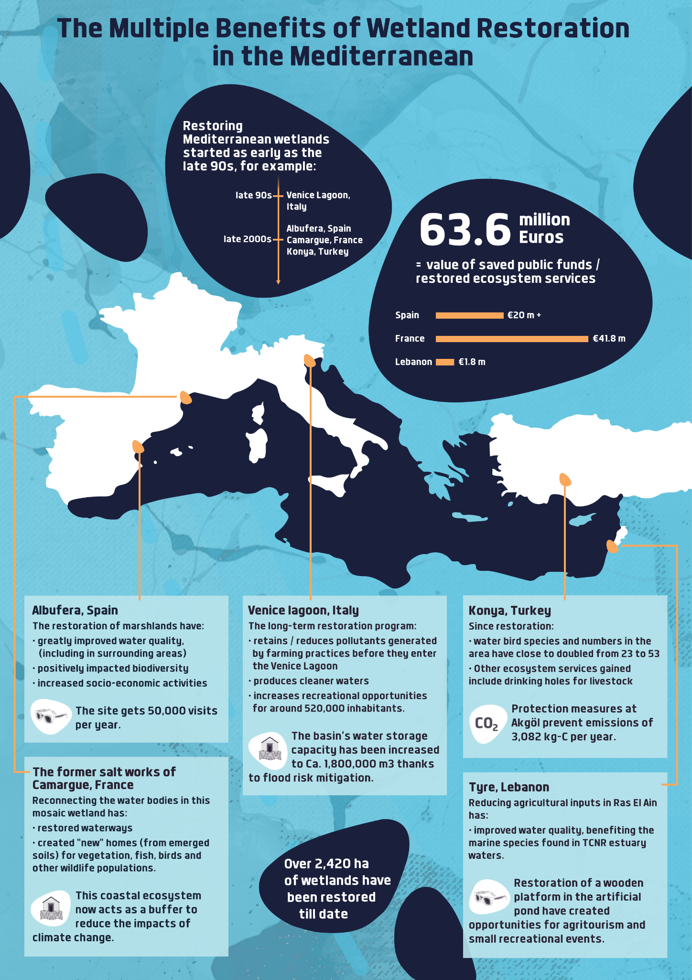

https://ec.europa.eu/jrc/en/publication/eur-scientific-and-technical-research-reports/mapping-and-assessment-ecosystems-and-their-services-eu-ecosystem-assessment
*Reference to the MBPC report on Mediterranean wetlands - permalink will be available on March 10, 2022*
Wetlands of the Balkan Mediterranean territory harmonised in a regional mapping. Greek Biotope - Wetland Centre (EKBY); University of Forestry, Sofia; National Environmental Agency of Albania; St. Kliment Ohridski University of Ohird; Terra Cypria; WWF-Greece. (Project WetMainAreas, co-funded by the European Union in the frame of INTERREG TNCP BALKAN-MEDITERRANEAN 2014-2020): http://185.17.146.157/maps/180
Mediterranean Island Wetlands Project, MedisWet: https://sites.google.com/view/mediswet
European Environmental Agency
https://www.hydrosheds.org
The representation of the Mediterranean countries includes all the contested and disputed borders in a different colour. These boundaries and names are those officially used by the United Nations Organization and the European Union and do not imply official endorsement nor acceptance by the authors. Country borders have been defined based on the “Countries 2020” dataset of the DG EUROSTAT “Geographic Information System of the Commission”
Collaborative work led by ETC-UMA under the Mediterranean Biodiversity Protection Community (MBPC) initiative with the support of Mediterranean Wetland Observatory, Tour du Valat, MedWet, Plan Bleu, and the partners of the WetMainAreas and MedIsWet projects
Data available at https://nature-art17.eionet.europa.eu/article17/
The data elaboration has been provided by the European Topic Centre on Biological Diversity (ETC/BD).
The Mediterranean Wetlands Initiative (MedWet; https://medwet.org/) brings together 28 Mediterranean and peri-Mediterranean countries and territories that are Parties to the Convention on Wetlands: Albania, Algeria, Andorra, Bosnia & Herzegovina, Bulgaria, Croatia, Cyprus, Egypt, France (overseas territories are not included), Greece, Israel, Italy, Jordan, Lebanon, Libya, Malta, Monaco, Montenegro, Morocco, Palestinian Authority, Portugal, Serbia, Slovenia, Spain, Syria, North Macedonia, Tunisia and Turkey
*Reference to the MBPC report on Mediterranean wetlands*
UNEP-WCMC and IUCN (2022), Protected Planet: The World Database on Protected Areas (WDPA) and World Database on Other Effective Area-based Conservation Measures (WD-OECM) [Online], February 2022, Cambridge, UK: UNEP-WCMC and IUCN. Available at: www.protectedplanet.net
Abdul Malak, D., Marin, A.I., Trombetti, M., San Roman, S., Carbon pools and sequestration potential of wetlands in the European Union, European Topic Centre on Urban, Land and Soil Systems, Vienna and Malaga, 2021, ISBN 978-3-200-07433-0.
Hendriks K, Susan Gubbay S, Arets E, Janssen J (2020) Carbon storage in European ecosystems; A quick scan for terrestrial and marine EUNIS habitat types. Wageningen, Wageningen Environmental Research, Internal Report. 66 pp.; 22 fig.; 22 tab.; 77 ref
Tomàs-Vives, P, T.Gil-Gil & C. Viada-Sauleda. Assessment and identification of potential wetlands to be restored in Mediterranean countries. WWF Spain & MAVA Foundation. 36 pp https://wwfes.awsassets.panda.org/downloads/final_report_survey_restoration_med_wetlands_2021.pdf
https://ec.europa.eu/environment/archives/greenweek2020/sites/default/files/2020-10/Public_Draft_Agenda_-_Green_Week__Final_Version.pdf

