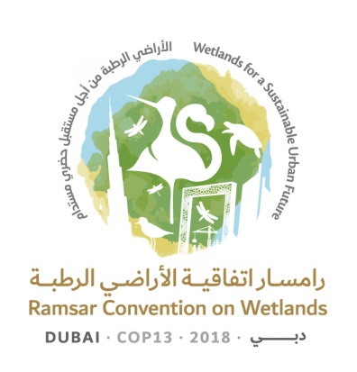
13th Meeting of the Conference of the Contracting Parties

to the Ramsar Convention on Wetlands

“Wetlands for a Sustainable Urban Future”

Dubai, United Arab Emirates, 21-29 October 2018

Ramsar COP13 Doc.18.24

Draft resolution on wetlands in West Asia

Submitted by Iraq

Note from the Secretariat

Following negotiations at the 54th meeting of the Standing Committee, which indicated that not all elements of the draft resolution were acceptable to all members, the Standing Committee adopted Decision SC54-21: “The Standing Committee instructed the Secretariat to edit, finalize and publish the draft resolution contained in document SC54-Com.5 for consideration at COP13, without further substantive amendment, noting that some Parties would raise concerns during COP13.”

1. GREATLY APPRECIATING the generosity of the United Arab Emirates in hosting the 13th meeting of the Conference of the Contracting Parties to the Ramsar Convention on Wetlands, which is being held for the first time in West Asia and which can be used as an opportunity to raise awareness of the importance of the wetlands in the region, their status as well as the issues and opportunities that they face;

2. RECOGNIZING the range of unique wetland types in West Asia, such as sabkha (salt-flats), khor (tidal inlets), and oasis (desert springs or water sources);

3. BEARING IN MIND that bilateral, regional and multilateral agreements between Contracting Parties to the Convention are in place and that nothing in the present Resolution undermines the provisions of those agreements;

4. RECALLING the importance for Contracting Parties of integrating wetland conservation and wise use into the management of their national as well as transboundary river basins, and the maintenance of environmental flows (Resolution VII.18 on Guidelines for integrating wetland conservation and wise use into river basin management), and of ensuring and protecting the water requirements of wetlands for present and future generations (Resolution XII.12 on Call to action to ensure and protect the water requirements of wetlands for the present and the future);

5. CONSCIOUS of the great importance of ensuring the conservation and wise use of wetlands in West Asia, and of encouraging cooperation between countries in the region in this respect;

6. CONCERNED over the degradation and drying of many wetlands, especially those that are shared, as a result of inter alia decreasing rainfall from a changing climate, over-extraction and mismanagement of water resources, and the construction of water control structures and extraction projects;

7. RECOGNIZING and REITERATING that the lack of water in wetlands is a far-reaching global problem with serious consequences for ecosystems and people’s livelihoods, in particular in vulnerable communities that depend on wetlands; and NOTING WITH CONCERN that this problem will tend to be aggravated in the future by the growing demand for water and other natural resources, in addition to potential effects of climate change (Resolution XII.12);

8. RECALLING United Nations General Assembly Resolution 72/225 on Combating sand and dust storms, the decision of the 13th meeting of the Conference of the Parties to the United Nations Convention to Combat Desertification 31/COP.13 on Policy Advocacy Framework to combat Sand and Dust Storms, and Resolution 2/21 of the second session of the United Nations Environment Assembly on Sand and dust storms expressing concerns on the severity of sand and dust storms impacting also wetland ecosystems, and outlining the need for actions to be taken; and

9. ALERTED to the increasing pressure on urban wetlands as well as the loss of natural coastal wetlands for various reasons, including over-control and overuse of water resources;

THE CONFERENCE OF THE CONTRACTING PARTIES

10. ENCOURAGES Contracting Parties that share the basins of rivers that flow through West Asia, especially the basin of the Tigris and Euphrates Rivers and their tributaries, to cooperate to maintain the environmental fresh water flow along the natural river so that the riparian countries are not adversely affected by development activities;

11. ENCOURAGES Contracting Parties in the west Asia Region to consider leveraging existing regional initiatives and commitments within the context of sustainable development to provide water for the environment and thus to strengthen wetland management;

12. Within the slogan “Wetlands for our future” CALLS FOR international support from Contracting Parties, Ramsar International Organization Partners (IOPs) and other relevant organizations, to carry out restoration of their ecosystem services as necessary so that wetlands can continue to benefit the affected people during recovery and into the future;

13. ENCOURAGES greater cooperation among Contracting Parties, the World Heritage Convention, IOPs and related organizations to promote awareness of the importance of the region’s wetlands and make practical efforts for their conservation and wise use, including exchange of experience and expertise, training and joint study; and

14. CALLS upon the Ramsar Regional Centre – Central and West Asia to follow up the provisions of the present Resolution, in the framework of its mandate, and report to the Conference of the Contracting Parties.

