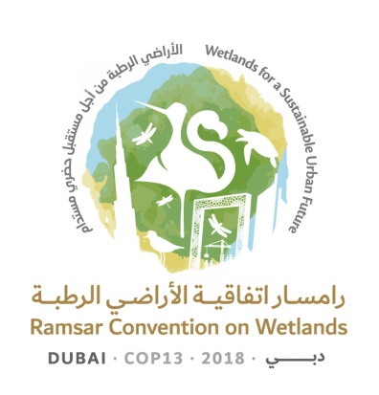
13th Meeting of the Conference of the Contracting Parties

to the Ramsar Convention on Wetlands

“Wetlands for a Sustainable Urban Future”

Dubai, United Arab Emirates, 21-29 October 2018

Ramsar COP13 Doc.18.23

Draft resolution on conservation and management of small wetlands

Submitted by China

1. RECALLING the commitments made by Contracting Parties in Article 3.1 of the Convention to promote, as far as possible, the wise use of wetlands in their territory and in Article 3.2 to maintain the ecological character of wetlands included in the Ramsar List of Wetlands of International Importance;

2. AWARE that wetland inventory has ignored wetlands of small sizes, and that there are major gaps in our understanding of small wetlands and their spatial distribution, connectivity and their networks around the world;

3. ALSO AWARE that small wetlands can be extremely vulnerable to environmental changes, in particular, climate changes, as well as to human development needs for land;

4. RECOGNIZING that small wetlands within a wetland complex can play important roles in hydrological cycles at catchment and larger scales, provide critical refuge for endemic amphibians and fishes, as well as breeding species; and FURTHER RECOGNIZING that small wetlands can often provide the same types of ecosystem services as larger wetlands;

5. ALSO RECOGNIZING that human settlements, villages and towns are often associated with small wetlands and that together they form important landscape heritage;

6. CONCERNED that small wetlands are increasingly facing development pressures; and EVEN MORE CONCERNED that these small wetlands are being lost to the expansion of agriculture, urban development including major cities, and other anthropogenic activities;

7. NOTING the efforts made by the European Pond Conservation Network and its Pro-Pond Project 2007-2010, the Small Wetlands Program of the United States Fish and Wildlife Service, as well as China’s “Strategy of Rural Revitalization”, which provide examples of small wetland conservation and management;

8. RECALLING Resolution VII.11 on Strategic Framework and guidelines for the future development of the List of Wetlands of International Importance (and the amended version of 2012 adopted through Resolution XI.8 on Streamlining procedures for describing Ramsar Sites at the time of designation and subsequent updates);

9. ALSO RECALLING Resolution XII.14 on Conservation of Mediterranean Basin island wetlands and Resolution VIII.33 on Guidance for identifying, sustainably managing and designating temporary pools as Wetlands of International Importance;

10. FURTHER RECALLING Recommendation 5.3 on The essential character of wetlands and the need for zonation related to wetland reserves; and

11. NOTING that conservation and management of the ecological character of small wetlands can contribute to the Sustainable Development Goals (SDGs), in particular SDG6, “Ensure availability and sustainable management of water and sanitation for all”, SDG11, “Make cities and human settlements inclusive, safe, resilient and sustainable”, SDG15, “Protect, restore and promote sustainable use of terrestrial ecosystems, sustainable manage forests, combat desertification, and halt and reverse land degradation and halt biodiversity loss” and SDG16, “Promote peaceful and inclusive societies for sustainable development, provide access to justice for all and build effective, accountable and inclusive institutions at all levels”;

THE CONFERENCE OF THE CONTRACTING PARTIES

12. CALLS UPON Contracting Parties to address urgently the significant human-induced pressures that threaten small wetlands, through promulgation of national and regional policy, and other effective measure to prevent the continuous loss of small wetlands;

13. INVITES Contracting Parties to designate key small wetlands for inclusion in the List of Wetlands of International Importance, in an effort to ensure the conservation of their biodiversity, and the maintenance of their ecological, cultural and social values;

14. ENCOURAGES Contracting Parties to produce science-based inventories of small wetlands, based on appropriate methodologies, and to integrate their information into national and regional land use plans, as appropriate;

15. ENCOURAGES Contracting Parties to ensure, as appropriate, that small wetlands are adequately reflected within communication, education, and public awareness activities, so as to enhance awareness of both decision makers and the general public;

16. INVITES the Contracting Parties and, as appropriate, the Secretariat to further promote the importance of small wetlands to the Convention on Biological Diversity (CBD), the Convention on the Conservation of Migratory Species of Wild Animals (CMS), and the High-level Political Forum on Sustainable Development;

17. INVITES the Contracting Parties to foster the wise use of small wetlands, as a means to advance sustainable development; and

18. INVITES all Contracting Parties to report on the status of small wetlands in their territory, as appropriate.

