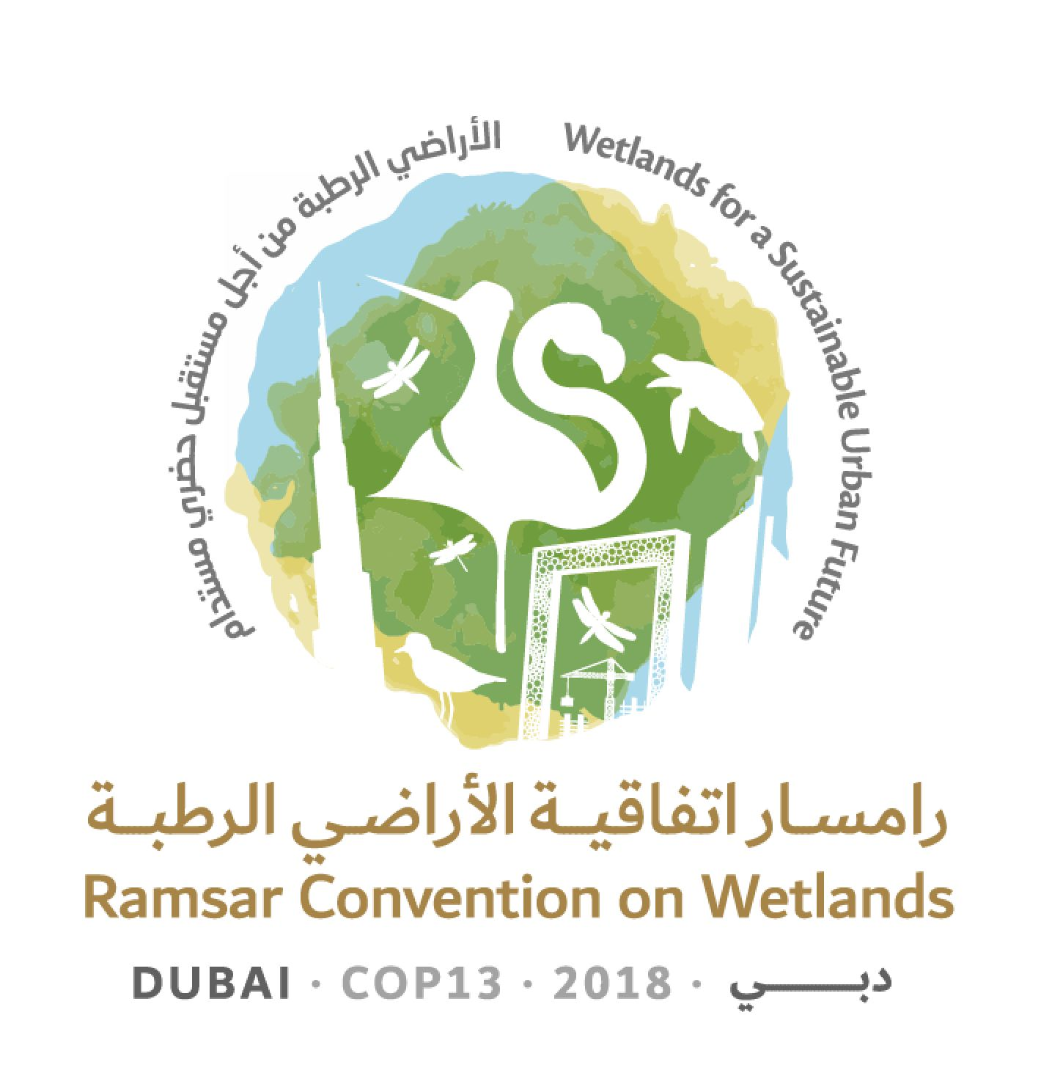
13th Meeting of the Conference of the Contracting Parties

to the Ramsar Convention on Wetlands

“Wetlands for a Sustainable Urban Future”

Dubai, United Arab Emirates, 21-29 October 2018

Resolution XIII.11

Ramsar Advisory Missions

1. RECALLING Recommendation 4.7 on Mechanisms for improved application of the Ramsar Convention which established that, when the Secretariat becomes aware that a Wetland of International Importance (Ramsar Site) is facing change in ecological character, where appropriate it is to propose a Ramsar Advisory Mission (RAM) to assist Contracting Parties to address such changes;

2. NOTING that, up to December 2016, across all Ramsar Regions, there had been 82 applications of this procedure, with positive results; and RECOGNIZING those Parties that have used RAMs in order to seek constructive solutions to challenges they face and as a contribution to their efforts towards effective implementation of the Convention;

3. RECOGNIZING the need to underpin and promote the greater application of the RAM as an important and useful tool for assisting Contracting Parties to implement the Convention;

4. FURTHER ACKNOWLEDGING the important contribution that the Scientific and Technical Review Panel (STRP), the International Organization Partners and other stakeholders have made to implementation of the RAM process over its 30-year history;

5. WELCOMING the STRP’s work in the past triennium to comprehensively review and analyse the body of reports from 82 RAM missions, and RECOGNIZING the STRP’s derived briefing note and policy brief on RAMs published in 2018;

6. NOTING that there has been no allocation from the core budget to support implementation of the RAM process since the seventh meeting of the Conference of the Contracting Parties, in 1999, but that non-core funding has been expended since this time to support 50 RAMs;

7. TAKING INTO CONSIDERATION that resources may not always be available to support RAMs in a timely manner; and ENCOURAGING Contracting Parties facing such situations to seek to identify other sources of support for RAMs; and

8. RECOGNIZING the additional value of RAMs in raising the Convention’s visibility, highlighting the commitment of Contracting Parties, and contributing to public awareness concerning wetland conservation and wise use;

THE CONFERENCE OF THE CONTRACTING PARTIES

9. CONSIDERS that the Ramsar Advisory Mission (RAM) mechanism is a useful tool available to Parties to assist with implementation of the Convention, constituting a means for providing independent advice relevant to addressing actual and potential change in ecological character at Wetlands of International Importance (Ramsar Sites);

10. ENCOURAGES Contracting Parties to consider requesting more frequent application of RAMs in their national territories in appropriate cases;

11. INSTRUCTS the Secretariat, when considering RAMs, to prioritize the application of RAMs for Sites that are facing problems similar to those at many other Ramsar Sites, where the RAM report may be of use for many other wetlands or where the RAM can add value to existing knowledge on how to address the described challenges;

12. INSTRUCTS Ramsar National Focal Points from Contracting Parties requesting RAMs to communicate with their national counterparts for other Conventions to identify opportunities to coordinate RAMs with other Conventions’ missions when applicable; and REQUESTS the Secretariat in responding to requests for RAMs to avoid duplication with other Conventions’ missions that may be undertaken, to the extent practicable;

13. URGES diligent follow-up by Contracting Parties hosting RAMs, to foster implementation of the recommendations made in RAM reports and to evaluate and report on the outcomes;

14. REAFFIRMS that RAM reports are public documents once the Party concerned has had an opportunity to approve them;

15. INSTRUCTS the Secretariat, in consultation with the Scientific and Technical Review Panel (STRP), to prepare operational guidance for RAMs, addressing inter alia the issues listed in Annex 1 to the present Resolution and giving due consideration to the briefing note and policy brief on RAMs published in 2018, to be submitted for adoption by the Standing Committee at its 57th meeting;

16. REQUESTS the Secretariat to ensure that regional expertise is included in RAM teams in order to leverage the knowledge and experience of national and regional experts, including from International Organization Partners, research and educational institutions, and civil society where relevant;

17. INVITES Contracting Parties, the private sector, financial entities and others in a position to do so to consider making additional voluntary contributions in support of RAMs; and FURTHER INSTRUCTS the Secretariat to consider the funding needs of the RAM mechanism in its Resource Mobilization Work Plan and in execution of its Work Plan;

18. THANKS the STRP for its useful work during the 2015-2018 triennium to review past RAM experiences;

19. REQUESTS the Secretariat, as appropriate and upon request, to advise Contracting Parties in their efforts to manage Sites on the Montreux Record and Sites for which reports on adverse change in ecological character have been received, engaging Regional Centres in such efforts as appropriate; and FURTHER REQUESTS the STRP, consistent with its scope, mandate, and priority thematic work areas for 2019-2021, in developing its proposed work plan for presentation at the 57th meeting of the Standing Committee, to consider working together with the Secretariat to support these efforts;

20. REQUESTS that the Secretariat develop an informational, downloadable brochure in all official languages explaining the opportunities presented by RAMs to assist Parties with implementing the Convention; and

21. FURTHER REQUESTS the Secretariat to promptly submit to the STRP all Contracting Parties’ requests for removal of Ramsar Sites from the Montreux Record and to expeditiously inform the Contracting Party and the Standing Committee of the STRP’s recommendation regarding the outcome of such requests.

Annex 1

Development of practical and technical operational guidance for Contracting Parties, the Secretariat and other stakeholders in the form of a simple “how to” step-by-step manual addressing inter alia the following topics

• Circumstances that trigger the proposed use of a Ramsar Advisory Mission (RAM)

• Links with Article 3.2

• Links with the Montreux Record

• Pre-RAM investigations and advice

• Prerogative of the Contracting Party to invite RAM / approve terms of reference (ToRs)

• Developing ToRs – standard good practice

• Scope of the RAM

• Coordination and team composition of mission team

• Timeframe considerations

• Role of the Secretariat

• Role of the Scientific and Technical Review Panel

• Role of International Organization Partners and other stakeholders

• Resourcing the RAM

• Application to candidate Ramsar Sites and other undesignated wetlands

• Application in transboundary contexts

• Operation on a joint basis with mechanisms of other multilateral environmental agreements

• Structure and contents of RAM reports

• The process for following up a RAM report

• Reporting on the activities of the RAM, including a review of outcomes an appropriate time after completion of the mission (typically about six years)

Briefing Note 8: Ramsar Advisory Missions - Technical advice on Ramsar Sites: https://www.ramsar.org/document/briefing-note-8-ramsar-advisory-missions-technical-advice-on-ramsar-sites; Policy Brief 3: Ramsar Advisory Missions - A mechanism to respond to change in ecological character of Ramsar Sites: https://www.ramsar.org/document/ramsar-policy-brief-3-ramsar-advisory-missions-a-mechanism-to-respond-to-change-in

